**NEC TK 80**

NEC TK 80

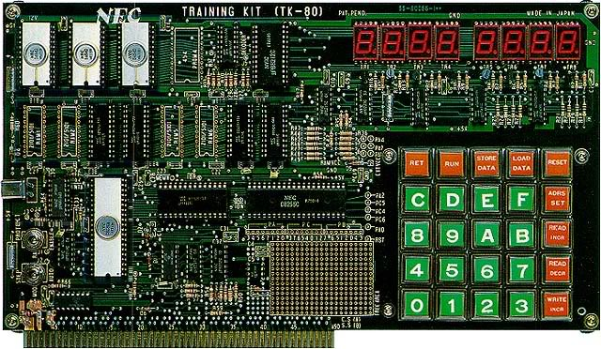

1976年，日本NEC推出日本第一台单板机TK80，装备Intel的8080A，ROM和RAM分别只有768byte和512byte。两年后的1978年，NEC推出了日本第一台个人计算机PC-8001。装备了日本自产的与Z80兼容的CPU，ROM和RAM分别提高到了24K和16K，可以运行BASIC和接显示器。

The NEC TK 80 is a 8080-cpu Training Kit (hence the "TK") computer sold at the end of the 70's. It is considered the first japanese home-computer. It was firstly aimed at technicians, but it met a great success with first computer hobbyists. It was often sold as a kit.

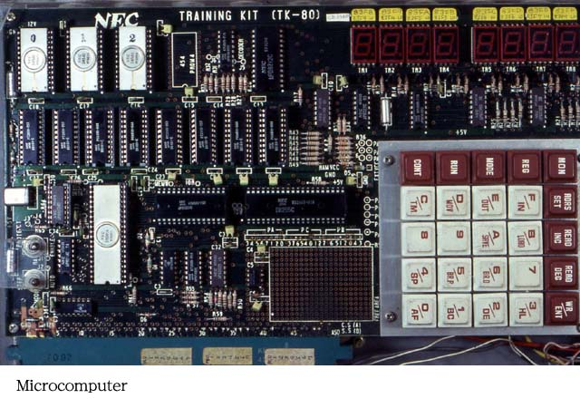

The systems is directly programmed in machine-code through the hexadecimal keyboard. There are 9 "function" keys on this keyboard : RET, RUN, STORE DATA, LOAD DATA, RESET, ADRS SET, READ INCR, READ DECR, WRITE INCR.  
Information is displayed on the built-in 7-segments LED display (1 line, 8 characters).   
  
The **TK-80E** is low-cost TK-80. The CPU and some chips are slightly different (uPD8080AD -> uPD8080AFC, uPD8228D -> uPD8228C, uPD454D -> uPD464C, uPD5101E -> uPD2101AL-4), thus reducing the production cost (ceramic -> plastic). Of course the TK-80E was less expensive.   
  
The **TK-80 BS** was a "Basic Station" model. It was composed of a TK-80 board with a BASIC ROM built-in, 7k RAM and an alphanumeric keyboard. Furthermore there was the Compo BS/80 which was a TK-80 with its Basic extension within a nice moulded plastic case.   
  
The TK-80 was used as a base for the PC-8001, the PC-8801 and the PC-9801.

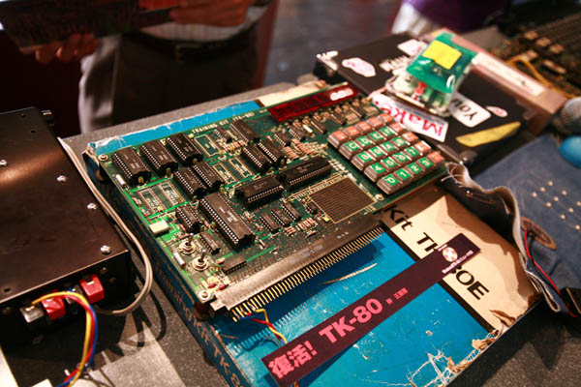

   二十世纪50年代初期，NEC与日本最早的通信器材制造商沖电气工业以及著名的富士通公司一起开始了战后日本最初阶段的计算机研究。60年代中叶，日本通产省面对美国计算机行业的发展，希望能够打造日本本土的计算机规格，但是在1973年，迫于美国的压力，日本被迫开放了计算机的进口自由化，这就使得以APPLE、IBM等美国厂商的电脑侵占了大量的日本PC市场。面对这种情况，SHARP（夏普）、TOSHIBA（东芝）、NEC（日本电气）、SANYO（三洋）、OKI（沖）、FUJITSU（富士通）等日本6大电器会社联合起来进行了所谓“IBM对抗机”的研发工作，而当时与NEC分作一组并肩作战的，是东芝公司。  
  
    1979年9月28日，NEC经过了之前的TK 80以及COMPO BS/80等机型的尝试，终于隆重推出了其新型个人电脑PC 8001，这是日本本土第一台成功的个人电脑，基于Z80核心，主频达到了4Mhz，分辨率达到160×100，可以显示8种色彩，价格是168000日元。而同期的的SHARP MZ 80K主频只有2Mhz，分辨率仅为80×50，10级灰度，价格却是198000日元。  
http://www.techcn.com.cn/uploads/201001/1262320394sjdCthci.gif

主要参数[回目录](http://www.techcn.com.cn/index.php?doc-view-140387.html" \l "section)

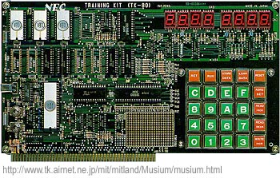

|  |  |
| --- | --- |
| http://www.techcn.com.cn/uploads/201001/1262320394GkDaYQyp.gif | http://www.techcn.com.cn/uploads/201001/1262320394sBp9sods.gif |

|  |  |
| --- | --- |
| **NAME** | TK 80 |
| **MANUFACTURER** | NEC |
| **TYPE** | Home Computer |
| **ORIGIN** | Japan |
| **YEAR** | 1976 |
| **KEYBOARD** | Hexadecimal keyboard, 25 keys TK-80 BS : full-stroke keyboard |
| **CPU** | 霵D8080AD |
| **SPEED** | 1.3 MHz |
| **RAM** | 512 bytes TK-80 BS : 5k |
| **ROM** | 2 kb ? |
| **TEXT MODES** | 8 characters x 1 line (7 segments LED display) TK-80 BS : 32 x 16 |
| **GRAPHIC MODES** | None |
| **COLORS** | None |
| **SOUND** | None |
| **SIZE / WEIGHT** | 310 ?180 mm |
| **I/O PORTS** | Expansion bus, EPROM sockets |
| **PERIPHERALS** | Optional cassette interface (300 bauds), RAM expansion, Basic ROM |
| **PRICE** | 88,500 Yen (Japan) |

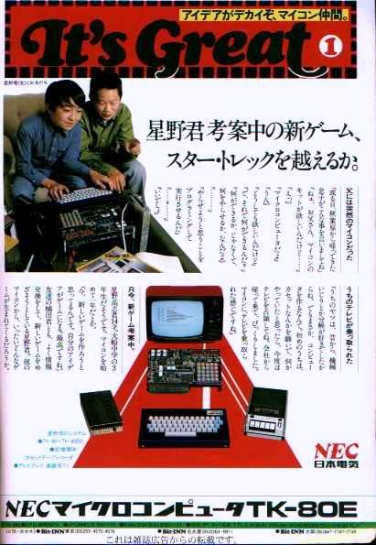

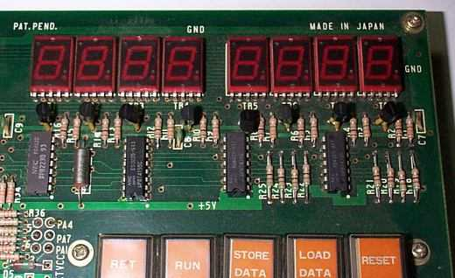

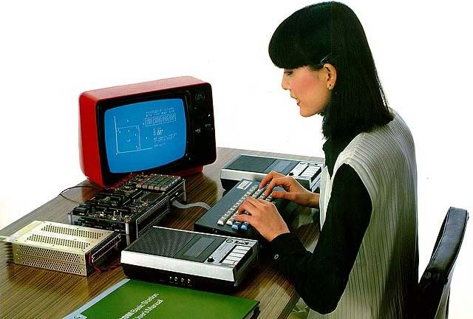

参考文献[回目录](http://www.techcn.com.cn/index.php?doc-view-140387.html" \l "section)

http://www.old-computers.com/museum/computer.asp?st=1&c=405